

|  |  |
| --- | --- |
| Refer to the figure at the right to answer the following.  1) Name a segment parallel to . | 1) _____________ |
| 2) Name a segment skew to | 2) ____________ |
| 3) Name a plane parallel to *QRUST* | 3)_____________ |

Use the drawing at the right to name the pair of angles described from the word box.

Then CIRCLE the *relationship* ***congruent or supplementary***

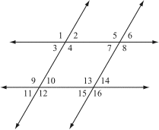

4) $<6 and <3 _____________________$

Congruent Supplementary

5) $<4 and <8_____________________$

Congruent Supplementary

6) $<9 and <12_______________________$

Congruent Supplementary

7) $<7 and <13_______________________$

Congruent Supplementary

8) $<5 and <7_____________________$

Congruent Supplementary

Same Side Interior

Corresponding

Alternate Interior

Alternate Exterior

Vertical

Linear Pair

|  |  |
| --- | --- |
| In the figure, . Find the measure of each angle.    9)  10) |  |
|  |  |
| 11) *Name* the special angle pair shown and describe their *relationship*  in the drawing. Then solve for x.  Image result for corresponding angles algebraa) | Name____________  Relationship__________  x=__________________ |
|  |  |
| b) | Name____________  Relationship__________  x=__________________ |
|  |  |
|  |  |

c) 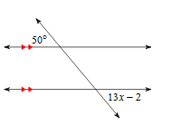

Name____________

Relationship__________

x=__________________